Project Development Phase
Model Performance Test

Date | 30 September 2026
Team ID | MKU201Team76ab4df35a238dc999eb5e6de
Project Name | Streamlining IT Procurement: Automating Standard Laptop Orders with Flow Designer
Maximum Marks

Model Performance Testing:
Project team shall fill the following information in model performance testing template.
S.No. | Parameter | Screenshot / Values
 | Data Rendered | Requested Item record RITM0010002 (Standard Laptop, Request REQ0010002) is rendered from the Service Catalog after clicking Order Now. Stage: Request Approved; State: Open; Quantity: 1.  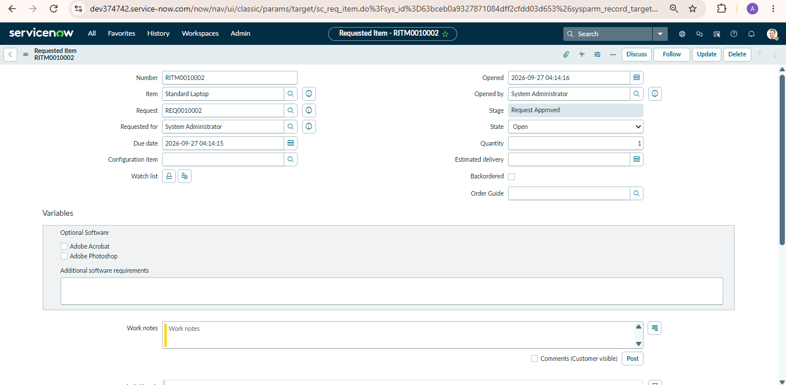
 | Data Preprocessing | No cleaning or transformation was required because the data is captured directly from the catalog order. In the “Standard Laptop Task” flow (Global application, Run As: System User) the Service Catalog trigger passes the Requested Item Record to the Create Catalog Task action, with the Short Description and Description set for laptop configuration.  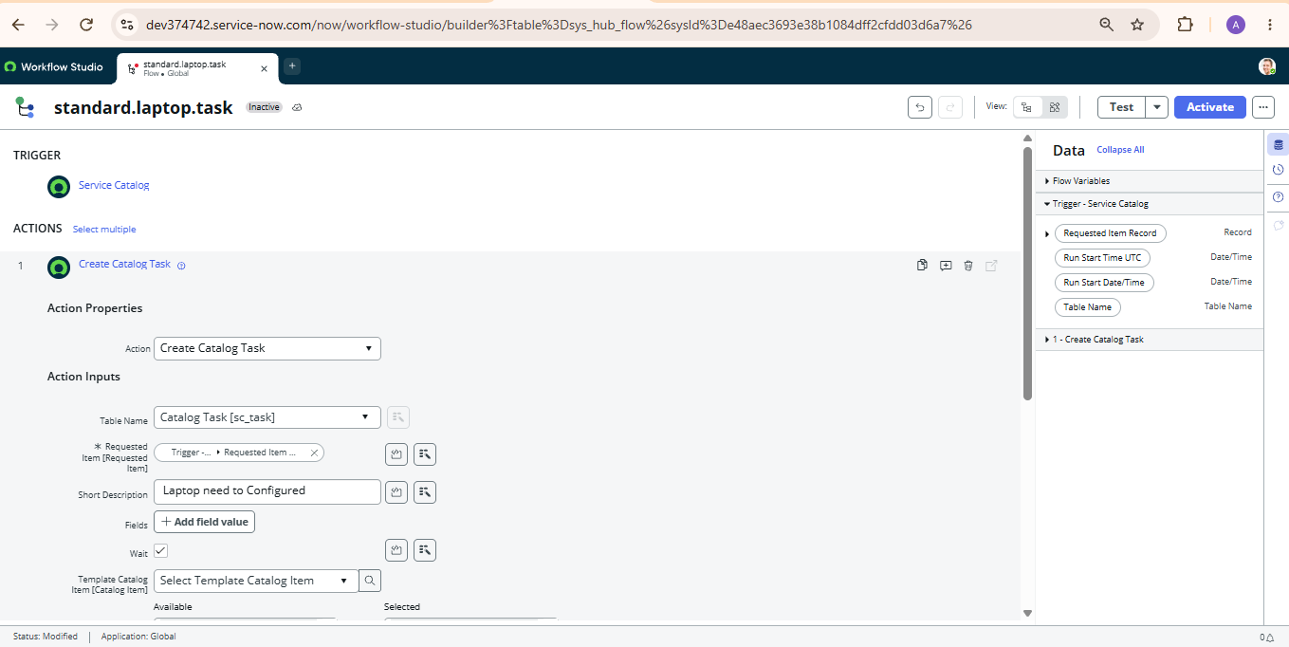
3. | Utilization of Data Filters | Catalog item “Standard Laptop” selected under the Hardware category of the Service Catalog; Process Engine set to Flow; task assignment filtered to the Hardware group; Approval value set to Approved.  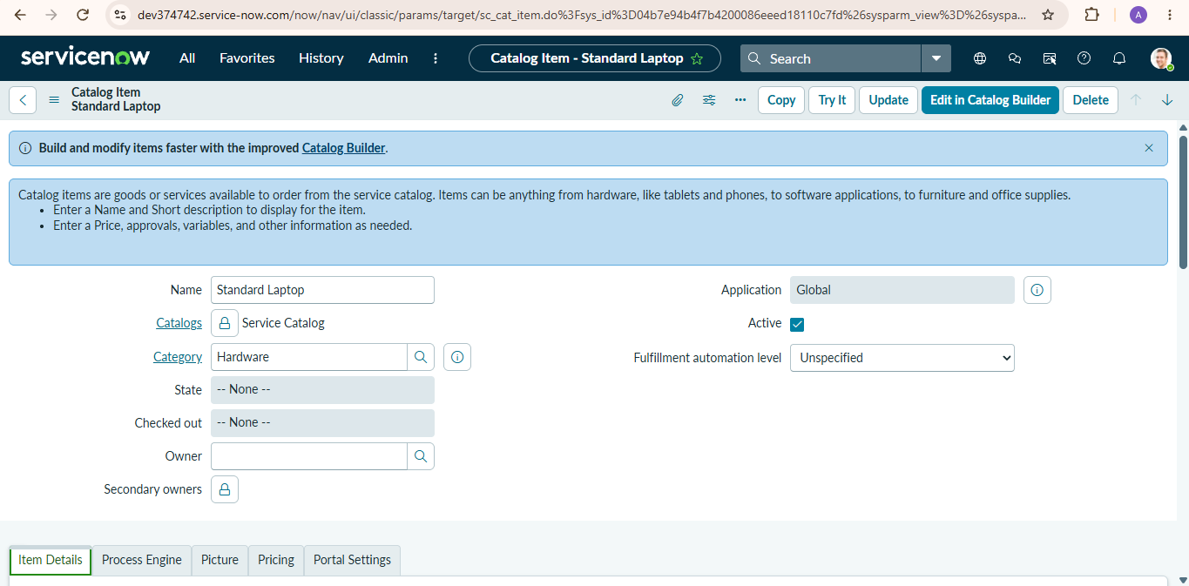
4. | DAX Queries Used | Not applicable – no DAX is used in this project. The equivalent logic is built with Flow Designer: Trigger – Service Catalog; Action 1 – Create Catalog Task (table sc_task, Requested Item = Trigger › Requested Item Record).
5. | Dashboard design | No of Visualizations / Graphs - 0  Flow Designer canvas with 1 trigger (Service Catalog) and 1 action (Create Catalog Task); the flow is activated after the confirmation prompt.  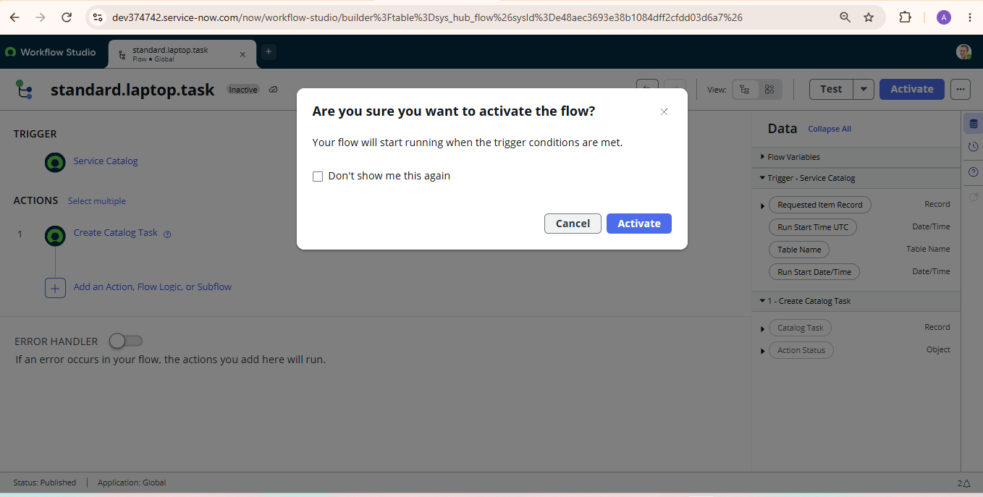
6 | Report Design | No of Visualizations / Graphs - 0  Output record: Catalog Task SCTASK0010002 created for RITM0010002 – Approval: Approved, State: Open, assigned to the Hardware team for laptop configuration.  